Mullings
(www.mullings.com)
An American Cyber-Column
2008 – Part I
Monday November 13, 2006
Do you think a pattern is emerging?
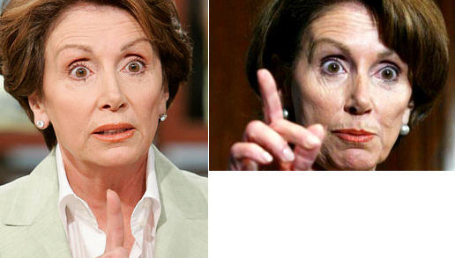
The MULLINGS Subscription Drive is still underway!
Please take a moment and go to the <a href = http://www.mullings.com/fall06_subs.htm> <b>Subscription Page </b></a>. Thank you for helping.

From Phoenix, Arizona
The Business Software Alliance
- Ok. The midterm elections are what were. The Presidential campaigns are what will be. Let’s take an early look. Today, the Democrats.
GENERAL THEORY:
- Both parties will have to decide whether they want to win, or are willing to lose on the point of an ideological sword.
- In California, Republicans - who tend to tile well to the Conservative end of the political scale - gave 91% of their votes to the decidedly moderate Governor Schwarzenegger. Winning was more important.
- Nationally, Democrats got a taste of what it’s like to win – something they haven’t savored since 1996. They may well decide, like California Republicans, that winning is worth ignoring – if not outright sacrificing – some deeply held beliefs.
- Let’s take a quick look at the Democratic frontrunners: Hillary Clinton, Barak Obama, Al Gore and John Kerry
- Hillary Clinton is at the top of every list. She spent $30 million (nearly $11 per vote) to get 67% of the vote against a badly flawed Republican candidate. Anything less – especially in a great Democratic year – and people would have wondered aloud whether she had lost a step.
- She spent the money and got the votes and now Democrats have to think about whether she will, as one national reporter put it “lead them off a cliff” by winning the nomination and losing the general election.
- Footage from election night – with Bill sharing the stage but grabbing everyone’s attention – while Hillary was giving her victory speech
- Biggest plus? Her name is Hillary Clinton. Biggest negative? His name is Bill Clinton and at the Presidential level, a spouse’s behavior counts. How many “bimbo alerts” will Hillary’s campaign have to explain away?
- Barak Obama is the media’s flavor-of-the-month. He has an almost non-existent legislative record as a US Senator which might work in his favor. Hard to pick apart a record which is largely blank.
- Obama has no experience at the national level where the unyielding glare of the political spotlight tends to make rookies wither as the unyielding pressures of constant campaigning and fundraising become crushing.
- The recent boomlet tells us Democrats may not be looking for an alternative to Hillary, but they certainly are looking at options.
- Biggest plus? He is a new face and has marvelous TV presence. Biggest minus? His name isn’t Hillary Clinton.
- Al Gore will go to his grave believing he was cheated out of the Presidency in 2000. A lot of Democrats agree with him. He has been through three national campaigns and knows the mistakes which he made, and which others have made on his behalf.
- His signature issue is Global Warming which will get him a great deal of positive press. No one has better bona fides on the issue, but it is hard to see how being a one-trick pony will be enough.
- Biggest plus? It may be eight-years-old, but he still has the fundraising list. Biggest minus? He is BIG. Al Gore is now so heavy you could hang ropes off him and use him as a float in the Macy’s Thanksgiving Day Parade.
- John Kerry is still up there in the minds of many rank-and-file Democrats as the best candidate for President. A recent poll – even after the “botched joke” – had him tied with Gore with 10 percent of Democrats saying they would like him to be the nominee.
- Kerry is up for re-election in 2008 and running for both President and Senator would be a tough juggle both from a time standpoint and on the fundraising front.
- Biggest plus? Theresa’s check book. Biggest minus? No sense of humor.
- Friday: The GOP frontrunners.
- On the <a href = http://www.mullings.com/dr_11-15-06.htm> <b>Secret Decoder Ring</b></a> page today: A link to a recent poll showing the early line on both Republican and Democratic candidates for President; a death-defying Mullfoto of a fire at Atlanta airport; and a content-appropriate Catchy Caption of the Day.

-- END --

