Mullings
An American Cyber-Column
America = France?
Wednesday, June 20, 2012
- The G-20 summit in Los Cabos, Mexico is, thankfully, over.
- During the proceedings we watched as President Barack Obama maneuvered himself into a position of being – if not totally inconsequential – certain a minor member of the chorus.
- From Woodrow Wilson to George W. Bush American Presidents have held the title “the most powerful man in the world.” Sometimes it was altered to “the most powerful man in the <i>western</i> world” but, you know what I mean.
- Barack Obama has not just allowed that label to lapse. He appears to have been happy to toss it aside.
- This isn’t about American exceptionalism. It’s about Obaman ordinariness.
- Obama is not First Among Equals at international meetings. At best he’s fourth among equals between Russia, China, and Germany. If you include Fed Chairman Ben Bernanke, Obama is no better than fifth.
- The Putin-Obama mini-summit in advance of the official meeting is a good case in point. CBS’ Nora O’Donnell described the scene following the two-hour sit-down:
“In their remarks after the meeting the two men barely looked at each other; you could just feel the tension between them, and the body language demonstrated how far apart the two leaders remain on the issue of Syria.
“Apparently, President Obama got a bit of a lecture from Putin about some other failed transitions that are going on around the world.
“It’s not clear how productive that meeting was.”
- The brilliant foreign policy analyst (and Mull-cousin) Michael Hirsh, writing about Obama in the National Journal, said the G-20 summit,
“… seemed to yield mainly defiance, and not just from unruly Russians like Vladimir Putin, who's doing his own thing in helping Syrian dictator Bashar al Assad, but even from the Western Europeans.”
- I am not suggesting that an American President has to be the Bully of the World. What I <i>am</> suggesting is that an American President – even this American President – commands the most powerful army in the world, oversees the largest economy in the world, and is the leader of the third-largest population in the world (behind China and India).
- As we awake this morning, the world is far more interested in what Angela Merkel is thinking with regard to bailing out Spanish Banks, what Vladimir Putin is thinking with regard to bailing out Syrian President Bashar al-Assad, or what Chinese Premier Hu Jintao is thinking with regard to bailing out the IMF and World Bank.
- If the 20th century was, as Harold Evans coined it in the title of his 1998 book, “The American Century” then the 21st Century may well be the Chinese Century.
- It’s a little early yet to give it a label. America didn’t take ownership of the 20th century until the closing months of WW I (which, as we mentioned before was called “The Great War” before we know we were going to have to number them) in 1917, so the Chinese have a couple of U.S. Presidential elections to go before they need to lay claim to the title.
- If that is the case then the U.S. will have to decide whether, in a Chinese-dominated world, we want to be the U.K. or France.
- The United Kingdom has kept its seat at the table even though its claims to glory and empire are long past. They have stepped up to the plate militarily, diplomatically, and economically when the world has needed them.
- France, on the other hand, has stood outside the coffee shop window, nose pressed against the glass, waving a sign saying “We’re still Important” causing the country at the cool kids table inside to roll their eyes and look away.
- Hirsh wrote in his National Journal piece that the Italian Prime Minister reminded reporters that the 2008 financial crisis began in America and
“European Commission President Jose Manuel Barroso declared, ‘Frankly we are not here to take lessons in democracy.’”
- At his press conference Tuesday night, Obama was on such sandy footing that his answers to reporters’ questions were rambling and almost non-responsive.
- In fact, I Tweeted this:
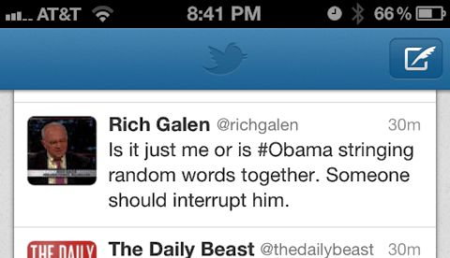
- Move away from the coffee shop window, Mr. President. You’re embarrassing us.
- On the <a href = “http://www.mullings.com/dr_06-20-12.htm”> <b>Secret Decoder Ring</b></a> today: Links to the Nora O’Donnell video, to the Michael Hirsh essay, and to the CIA’s World Factbook list of populations.
Also another in the never-ending series of photos from my trip to France, and a <i>very</i> topic-appropriate Catchy Caption of the Day.

-- END --

