Mullings
An American Cyber-Column
What’s in it for Putin?
Rich Galen
Thursday, April 10, 2014
- The situation in Ukraine is going in the wrong direction at increasing speed.
- Here is a map of Ukraine so you can follow along:

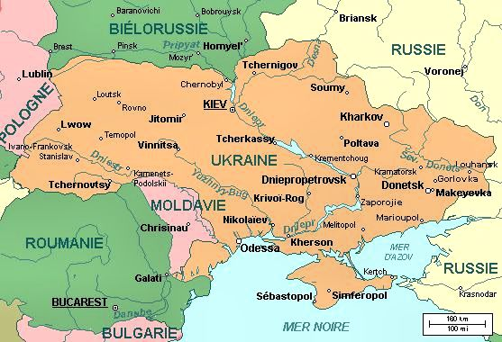

- Note, that Kiev – the capital of Ukraine - is about 2/3 the way up. If you look to the farthest south (about 5:30 from Kiev) that peninsula is Crimea.
- Over on the eastern (right-hand) border with Russia is Kharkov (English spelling: Kharkiv) – the second largest city in Ukraine where the action shifted over the weekend.
- Also note, on the western (left) side of the map, Moldavia (the pink area between Ukraine and Romania). There is a little strip between the western border with Ukraine and what looks like a river. This is known as Transnistria and claims it is an independent republic.
- Just the right of Moldavia (back in Ukraine) along the Black Sea find Odessa.
- Ok? Let’s go.
- I have been wondering why Vladimir Putin is taking it upon himself to raise the temperature of the Western Alliance by being so aggressive about Ukraine. I poked around for a while then decided my best bet was to talk to a friend of mine who has spent the better part of the last 20 years working in, and thinking about, that region.
- I can’t use his name or affiliation, so you’ll just have to trust me that he actually exists.
- And I asked him: What’s in this for Putin?
- He said that there are people – and Putin appears to be one of them – who cannot come to grips with the fact that Ukraine might align with the European Union.
- Think about it this way. What if Mexico was the dominant country in North America and decided that it could no longer abide the fact that Arizona was ceded to the US in 1848, and New Mexico in 1853.
- Lets say Mexicans believed that the history, the culture and (for a huge percentage of the population) the language was Spanish not Anglo Saxon.
- And, they wanted them back.
- California, which became a territory of the U.S. in 1847, is not on the table, just as Western Ukraine is not – as yet – for Putin.
- Russians generally, and Putin in particular, could not abide having a truly independent Ukraine join with the EU, and potentially NATO.
- Crimea was part of Russia (not Ukraine) until 1954 when Nikita Khrushchev transferred it to Ukraine by order of the Supreme Soviet. Sort of like President Barack Obama issuing a Presidential Order to delay the effective dates of portions of Obamacare.
- This year, Putin wanted Crimea back, and he took it.
- Now the Russians have massed tens of thousands of troops along the border with Ukraine and, we believe, have paid agents to seize the government buildings in the provinces along the eastern border to force the same kind of referendum that the Russians staged in Crimea.
- Now, look at that sliver of land, Transnistria, I pointed out in Moldova. The reason the Russians might have designs on that has nothing to do with Transnistria, it has everything to do with the fact that, if the Russians moved troops into that sliver of land they could move armored units into Odessa in about three hours.
- Why does Odessa matter? Without Crimea, it is the last warm-water port available to Ukraine. Without Odessa, Ukraine is a land-locked nation.
- My friend said he believed that Putin’s concern was that a Western-facing Ukraine might create political unrest in the Motherland.
- While Putin is loudly protesting that freedom of expression must be guaranteed in eastern Ukraine, handing out anti-government pamphlets in Russia is likely to lead to a fine or jail.
- My friend told me a sidebar which I will share with you here:
SIDEBAR
The Foreign Minister of and Eastern European nation met with Obama’s National Security Advisor, Susan Rice. Given the Russian economy’s dependence on oil and gas, the Minister suggested the U.S. take two relatively easy steps to show Vladimir Putin we were serious:
- Release oil from the Strategic Petroleum Reserve to lower the price of international oil.
- Approve all pending licenses to ship liquefied natural gas to Europe.
According to my friend, Dr. Rice said those were short-term actions and President Obama wanted a long-term solution.
“What would that be,” asked the Minister?
“That’s a work in progress,” Rice answered.
<sigh>
END SIDEBAR
- This year the Orthodox and the Western Christian date for Easter happen to overlap and the betting in the region is that nothing will happen until after Easter.
- An election for President of Ukraine is scheduled for May 25. The government in Kiev expects Putin to work every day between now and then to destroy the world’s confidence that Ukraine can run that election and choose a new government so that the results of the election are left in doubt.
- Vladimir Putin didn’t feel strong enough after the Orange Revolution to intervene in Ukraine. Ten years on, he feels empowered and sees is little or no Western opposition to him working his will there.
- On the <a href = “http://www.mullings.com/dr_04-10-14.htm”> <b>Secret Decoder Ring</b></a> page today: A map of where the Ukrainian and Russian speakers are, and links to the transfer of Crimea to Ukraine, Russia’s designs on Moldova, and the Orange Revolution.
Also the Mullfoto of a poster I have hanging on my wall that is very poignant given what is going on in Ukraine.

-- END --

