Mullings
An American Cyber-Column
Inaugurals
Rich Galen
Monday, January 16, 2017
- Friday is Inauguration Day. Even if I didn’t live just across Potomac River from Washington, DC, and even if my office weren’t six blocks from the White House, I would know this is Inaugural week because this will be a two-day work week for many of us in Our Nation’s Capital.
- Today is Martin Luther King, Jr. day which is a holiday so no work. Tuesday and Wednesday are regular office hours. The road closings and security arrangements begin to kick in at midnight Thursday morning so many offices are making that a “best effort” work day.
- Friday is Inauguration Day, the day when 700,000 (or so) people who have no idea where they’re going or how to get there will have shown up to celebrate Donald J. Trump’s swearing-in.
- Because of the nature of this year’s election, those 700,000 will be check-by-jowl with another couple of hundreds of thousands of people who will be in town to demonstrate <i>against</i> that same Donald J. Trump’s swearing-in.
- Nearly a million people who don’t know Washington, DC and don’t like each other is pretty much my working lifetime answer to the question: Around whom would you least like to be on Friday, January 20, 2017?
- Like most things in America, Inaugurations have grown and grown and grown since the first one. That would have been George Washington’s swearing-in on April 30, 1789. The new Constitution (having replaced the Articles of Confederation) went into effect on March 4, but neither the House nor the Senate, meeting in New York City, could raise a quorum and so the Electoral Votes could not be counted.
- They finally got enough Members of both houses to NYC on April 6 when the votes were counted, Washington was certified as the President (with John Adams proclaimed VP) but Washington wasn’t hanging around buying Manhattans for the Members, he was at home in Mount Vernon and wasn’t official informed of the outcome until April 14, 1789.
- That was not because the Russians had hacked Washington’s email, it was because there was no FedEx or UPS with next-day delivery services.
- Here’s a painting of George Washington taking the oath at Federal Hall by Spanish painter Ramón de Elorriaga (1836-1898):
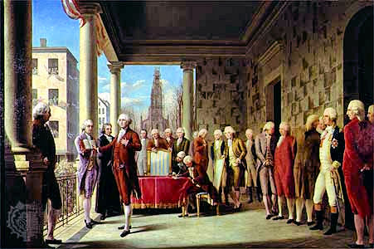
Compare and contrast with this photo of Sen. Barack Obama taking the oath eight years ago:
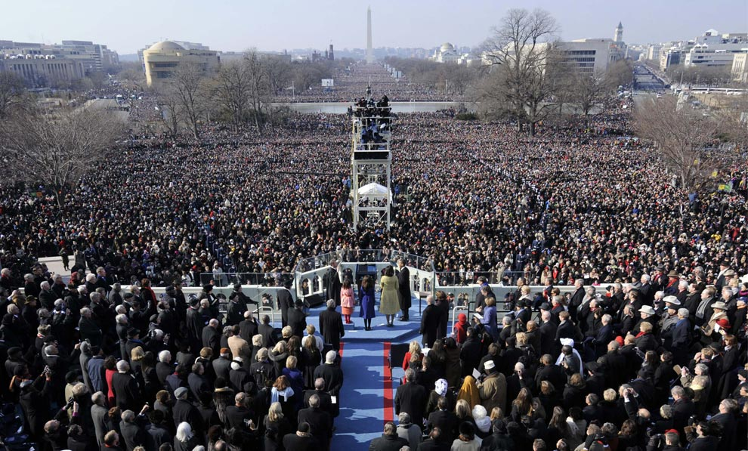
- It is fiction that this is the first time the losers have not come to grips with dealing with the winner taking the oath.
- The 2000 election was held on November 7 but wasn’t officially decided until the Supreme Court ruled on the Florida recount on December 12. George W. Bush won Florida by 537 votes, but lost the national popular vote to Al Gore by 543,895.
- Talk about claims of an illegitimate President. There were people who, in 2005 when the Washington Nationals came to town, would <i>still</i> not wear the home team’s baseball cap because it had a “W” on the front.
- Ronald Reagan’s second swearing-in in 1985 was held indoors in the Capitol Rotunda because of, as USA Today reported, “wind chills as low as 20 degrees below zero.” So, a <i>lot</i> of people didn’t attend.
- Tickets to the actual swearing-in are officially free. Like everything else, who you know goes a long way toward whether your free ticket is in the seated area in front of the West Front of the Capitol, or a half mile away standing in the wet grass on Smithsonian Mall.
- Members of Congress and Senators get those free tickets to distribute but you don’t have to be a U.S. Attorney to guess which constituents are likely get which tickets.
- The swearing-in is the only official element of the operation (other than signing official papers and maybe peeking into the President’s Book of Secrets later). The parade is traditional and free for those who want to line the route. The Inaugural Balls, dinners, and concerts are not paid for with public funds (other than security costs). They are supported by donors who actually buy tickets.
- I have a pretty good Inaugural Dinner story, I’ll share with you on Thursday.
- The Presidents’ inaugural addresses are about the only things that have any enduring significance. We’re only a few days away from seeing how President Donald Trump meets that test.
- <P><LI>On the <a href = “http://www.mullings.com/dr_01-16-17.htm”> <b>Secret Decoder Ring</b></a> page today: Links to Washington’s Inaugural, the Florida Recount, and the USA Today’s weather article.
The Mullfoto is of a mounted set of Inaugural Tickets hanging in Mullings Central.

-- END --

